**27. JUNIT TESTING TO CHECK WHETHER THE GIVEN STRING IS GETTING REVERSED OR NOT**

**AIM**

To Perform Junit Testing to Check Whether the given string is getting Reversed or not

**PROGRAM**

package sse;

import static org.junit.Assert.assertEquals;

import java.util.Scanner;

public class reverse

{

public static void main(String[] args)

{

String str;

char ch;

Scanner sc=new Scanner(System.in);

System.out.print("Enter a string : ");

str=sc.nextLine();

System.out.println("Reverse of a String '"+str+"' is :");

for(int j=str.length();j>0;--j)

{

System.out.print(str.charAt(j-1));

assertEquals("mani",str);

}

assertEquals("mani",str);

}

}

**OUTPUT**

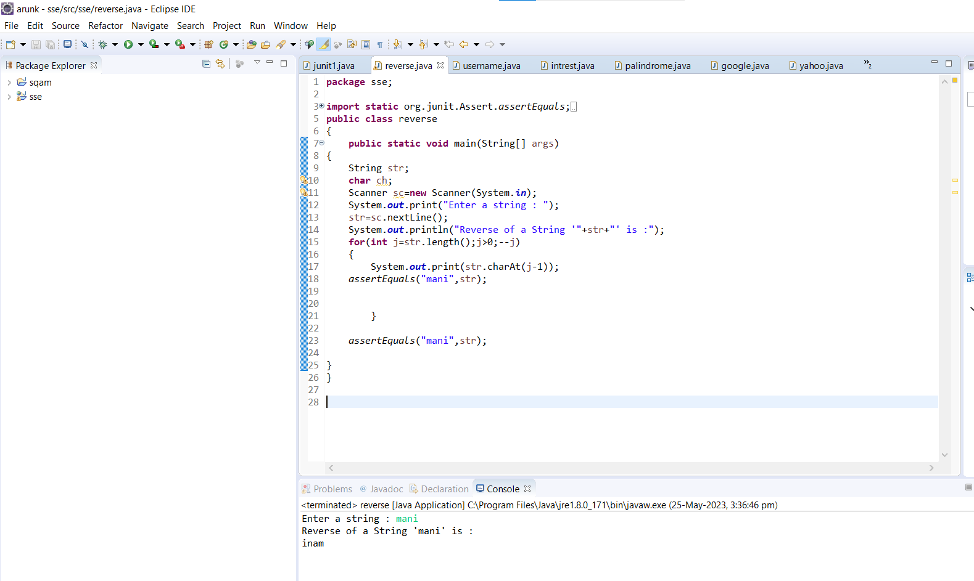

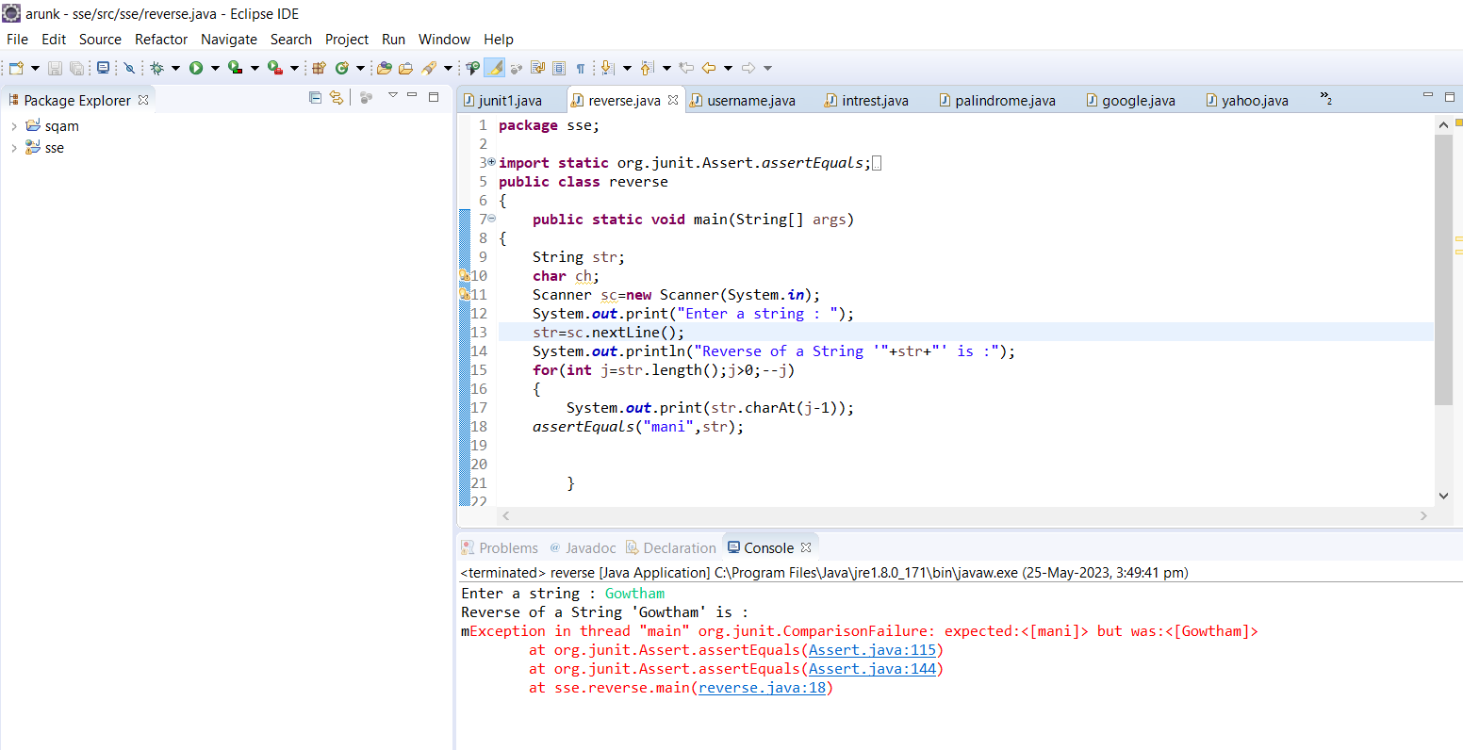

**RESULT**

Hence the Junit Testing to Check Whether the given string is getting Reversed or not performed successfully.